**Tableau- Assignment 7**

1. Using the concept of Exclude-LOD, create a view / worksheet that shows the sales by region, by state and by city in parallel with the dimensions, “Region”, “State” and “City”. Use the Global Superstore Orders 2016 dataset.

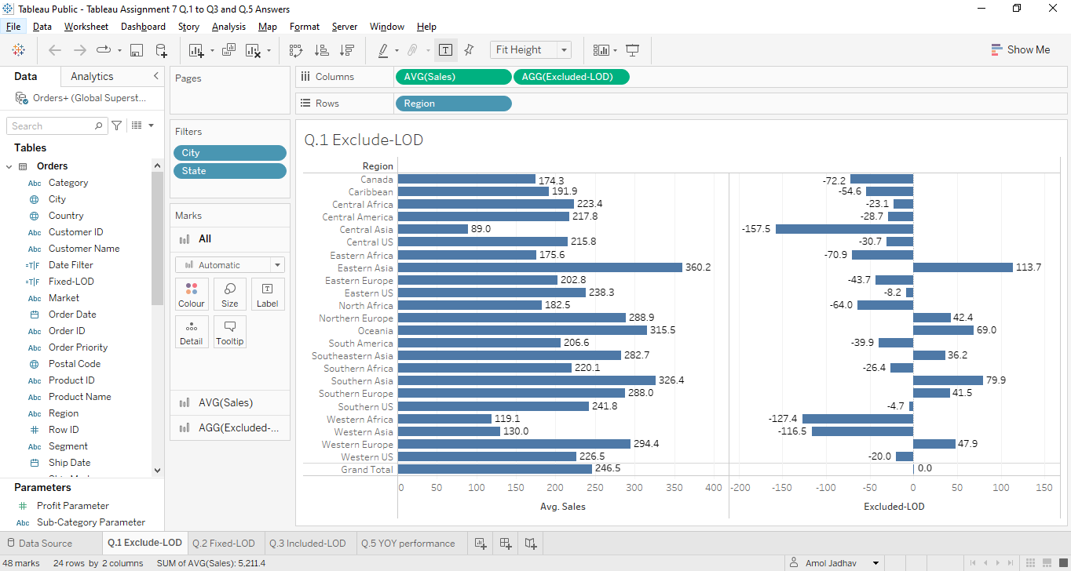

1. Calculations for Fixed-LOD are independent of the view. Regardless of what is or is not included in the view, they simply concentrate on the dimension that we utilize in the "Fixed LOD Calculations." With respect to the information shared above, create a view / worksheet that shows the sales by region, by state and by city in parallel with the dimensions, “Region”, “State” and “City” keeping the sales constant w.r.t to the dimensions used in the view. Name the custom LOD calculations with the suffix “Fixed”. Use the Global Superstore Orders 2016 dataset.

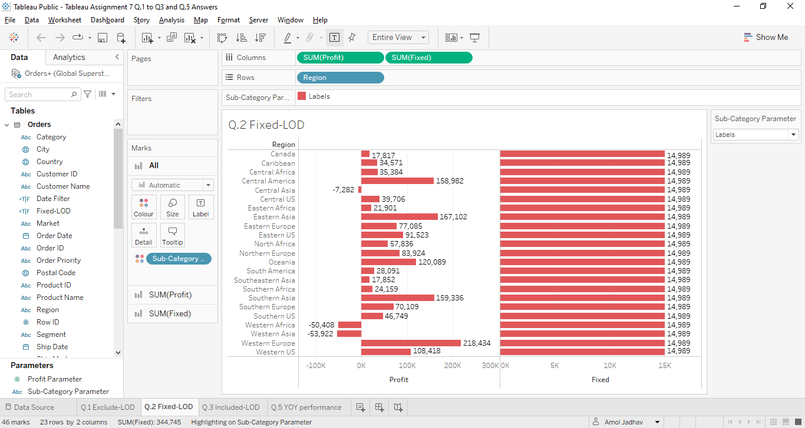

1. Using the concept of Include-LOD, create a view / worksheet that shows the "Average Sales Amount" for all of the customers and "Average Transaction Amount per Customer" in the same sheet. Use the PowerStore_USA dataset. (Hint: Add up all of the client sales to get the "Average Sales Amount," then divide by the total number of customers. Combine the transaction amounts for each client, then add the totals for all customers to obtain the "Average Sales Amount per Customer.

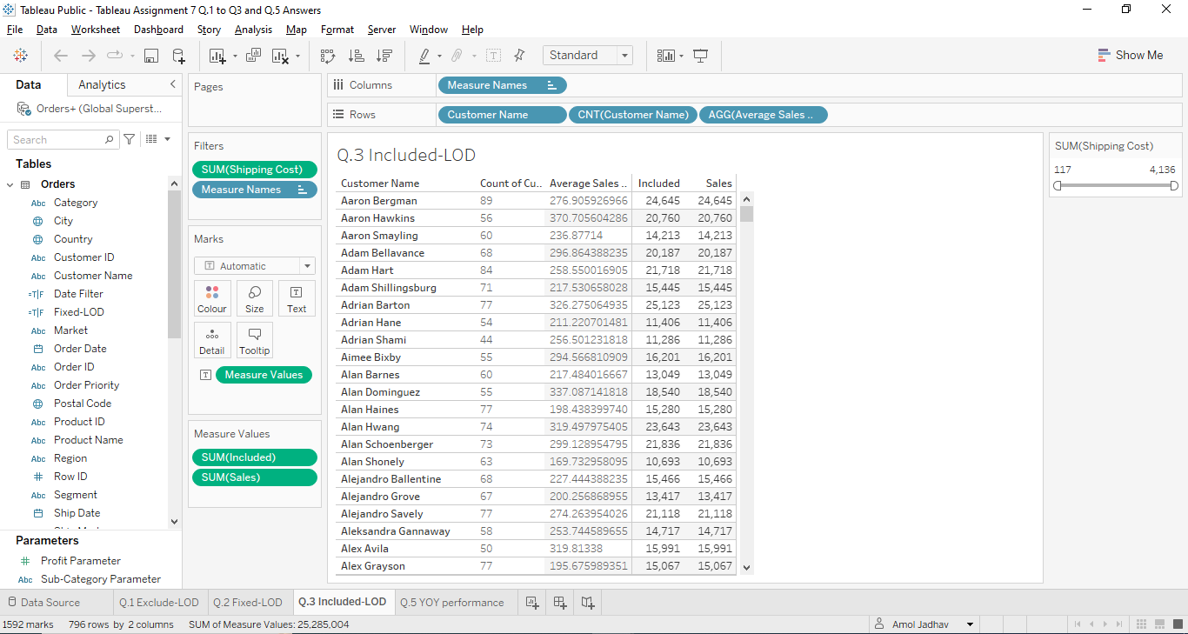

1. The data set is divided into 100 equal sections using percentiles. Percentiles calculate starting position. They are employed to assess a person's position within the population. In other words, they reveal a person's rank standing. Prepare a dummy data for students enrolled in iNeuron’s Data Science Course with columns (Roll Num, Marks) with the number of rows of your choice. Create a view showing the percentile for data science students enrolled in iNeuron’s Data Science Course based on their scores.

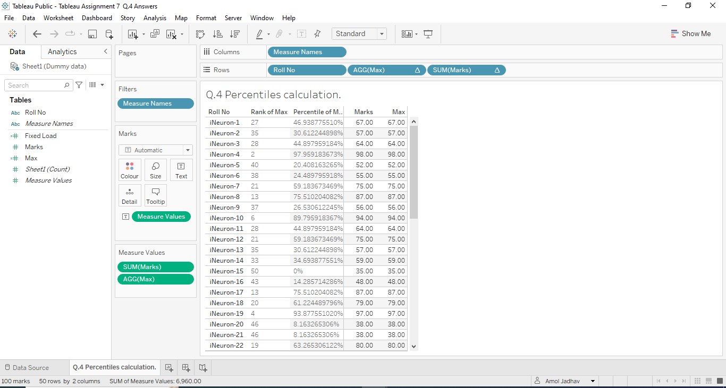

1. The company's financial performance this year in comparison to last year is referred to as YOY. The YOY performance is used to determine if the company's performance is deteriorating or improving. Using the Global Superstore Orders 2016 data, create a visualization of the company's year-over-year growth for a period of 4 years.

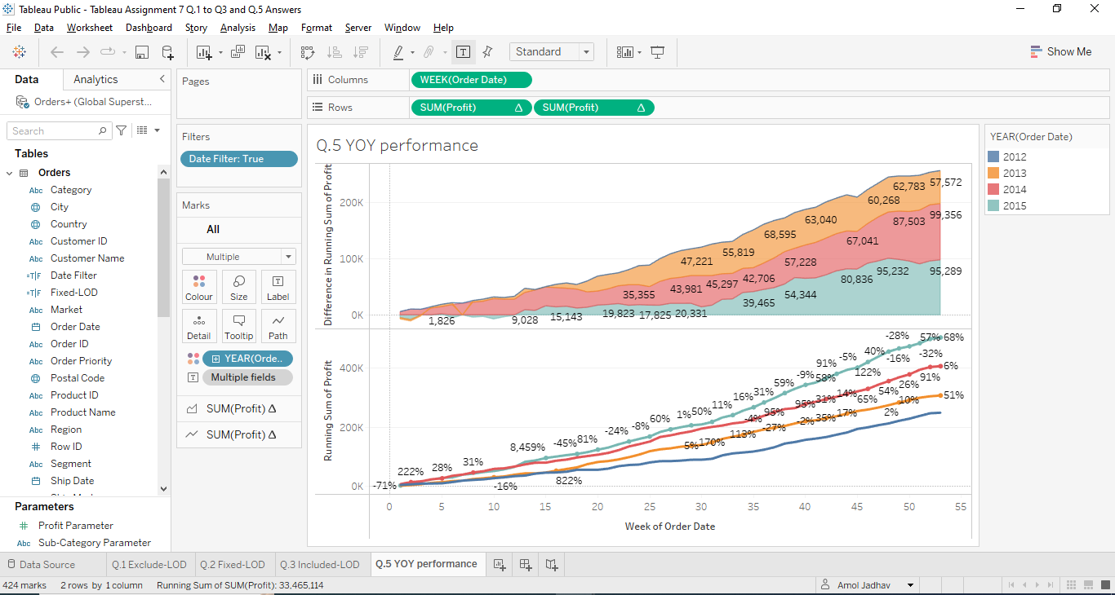

[*PFA links for the datasets used.*](https://drive.google.com/drive/folders/123UyMRbrReCjyn1K4g_FhsjKx6cP4zLH?usp=sharing)